COMMUNITY-POWERED BLUEPRINT
Anticipatory Crisis Management Plan - Light
Community Version - Champaign-Urbana


Adobe Stock: 841230815
Preparing communities before emergencies happen.
Developed By
Melissa Kaye Swaney
M.A. Communication & Leadership
Eastern Illinois University
Website:
WELCOME HOME | Community Blueprint
Contact:
communitypoweredblueprint@gmail.com
The Community-Powered Blueprint is a free educational and community preparedness project created to encourage discussion, planning, preparedness, and stronger local support systems. This blueprint is not being sold and is intended to be accessible to the community.

TABLE OF CONTENTS
TABLE OF CONTENTS 3
Introduction 6
What Is Community-Powered Blueprint? 6
A. HOUSING POD 7
Purpose 7
Examples of Support 7
Examples of Community Support Systems 8
Community Skills & Volunteers Needed 8
B. FOOD POD 9
Purpose 9
Examples of Support 9
Examples of Community Support Systems 10
Community Skills & Volunteers Needed 10
C. CLEAN WATER POD 11
Purpose 11
Examples of Support 11
Examples of Community Support Systems 12
Community Skills & Volunteers Needed 12
D. SURVIVAL SKILLS & SELF-RELIANCE POD 13
Purpose 13
Examples of Support 13
Examples of Community Support Systems 14
Community Skills & Volunteers Needed 14
E. LEGAL & JUSTICE POD 15
Purpose 15
Examples of Support 15
Examples of Community Support Systems 16
Community Skills & Volunteers Needed 16
F. COMMUNICATION & OUTREACH POD 17
Purpose 17
Examples of Support 18
Examples of Community Support Systems 18
Community Skills & Volunteers Needed 18
G. RESOURCE & FUNDING POD 19
Purpose 19
Examples of Support 19
Examples of Community Support Systems 20
Community Skills & Volunteers Needed 20
H. MEDICAL & HEALTHCARE POD 21
Purpose 21
Examples of Support 21
Examples of Community Support Systems 22
Community Skills & Volunteers Needed 22
I. MENTAL HEALTH & EMOTIONAL SUPPORT POD 23
Purpose 23
Examples of Support 23
Examples of Community Support Systems 24
Community Skills & Volunteers Needed 24
J. POWER & ENERGY POD 25
Purpose 25
Examples of Support 25
Examples of Community Support Systems 26
Community Skills & Volunteers Needed 26
K. EDUCATION & JOB TRAINING POD 27
Purpose 27
Examples of Support 27
Examples of Community Support Systems 28
Community Skills & Volunteers Needed 28
L. TRANSPORTATION POD 29
Purpose 29
Examples of Support 29
Examples of Community Support Systems 30
Community Skills & Volunteers Needed 30
About the Creator 31
Independent Community Preparedness Disclaimer 31
Organizations & Community Participation 32

Introduction
Every day, we hear about problems in the news, on social media, from podcasters, and in conversations with family members, friends, neighbors, and coworkers.
We hear concerns about rising costs, disasters, housing, healthcare, food insecurity, isolation, transportation, emergencies, and uncertainty about the future.
Eventually, many people begin asking:
“What do we do?”
I have an answer. A community-powered blueprint.

What Is Community-Powered Blueprint?
The Community-Powered Blueprint is a practical 12-pod community support framework designed to encourage preparedness, communication, resource-sharing, and stronger local support systems before emergencies or hardships become more severe.
The following pods are examples of ways communities may be able to work together to strengthen support systems involving critical resources, services, preparedness, and community care.


Adobe Stock: 840349678

A. HOUSING POD

Purpose
The Housing Pod focuses on helping community members find safe, stable shelter during times of crisis, displacement, financial hardship, natural disaster, or community disruption. Its purpose is to strengthen local support systems by preparing communities to work together before emergencies happen.
This pod encourages communities to identify available housing resources, temporary shelter options, shared spaces, accessibility needs, and long-term recovery support in advance rather than waiting until a crisis occurs.

Examples of Support
- Temporary emergency shelter coordination
- Repurposing unused buildings or community spaces
- Shared housing and roommate assistance
- Hotel and motel partnership support
- Housing resource navigation and referrals
- Eviction prevention support and resource connection
- Emergency warming and cooling shelters
- Assistance for seniors, people with disabilities, and vulnerable populations
- Transportation coordination to safe shelter locations
- Community safety check-ins during emergencies

Examples of Community Support Systems
(Examples only. Inclusion does not imply formal participation or endorsement.)
- Housing assistance organizations
- Local shelters and transitional housing programs
- Churches and faith-based organizations
- Community planning organizations
- Community assistance programs
- Housing authorities and property managers
- Local landlords and real estate professionals
- Community centers and schools
- Hotels and motels willing to assist during emergencies
- Nonprofit outreach organizations
- Volunteer and neighborhood support groups

Community Skills & Volunteers Needed
- Contractors and construction workers
- Electricians, plumbers, and maintenance workers
- Realtors and housing advocates
- Volunteers willing to organize supplies or assist families
- Drivers and transportation volunteers
- Community outreach workers
- Safety coordinators
- People willing to help identify available spaces or resources
- Social workers and case management professionals
- Neighbors willing to support vulnerable residents during emergencies

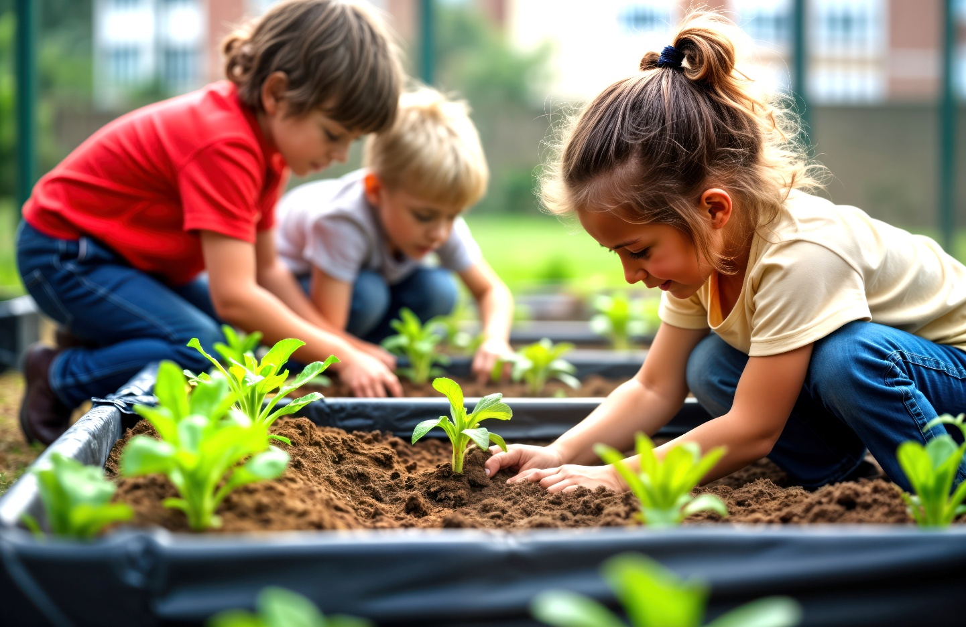
Adobe Stock: 1223985026

B. FOOD POD

Purpose
The Food Pod focuses on helping communities improve food access, food security, meal support, gardening, farming, and local food distribution during times of crisis, hardship, or disruption. Its purpose is to encourage communities to prepare ahead of time by organizing food resources, teaching practical food-growing skills, and supporting vulnerable individuals who may struggle to access meals.
This pod encourages communities to work together to strengthen local food systems, reduce food insecurity, and support one another before emergencies become more severe.

Examples of Support
- Community gardens and local food-growing projects
- Food pantry support and meal distribution
- Meal preparation and delivery for elderly, disabled, ill, or homebound individuals
- Emergency food supply coordination
- Gardening, farming, and food preservation education
- Partnerships with local farms, grocery stores, and food providers
- Food donation drives and community meal events
- Nutrition and basic cooking education
- Transportation support for food delivery and pickup

Examples of Community Support Systems
(Examples only. Inclusion does not imply formal participation or endorsement.)
- Food assistance programs
- Community meal support organizations
- Local farms and farmers markets
- Community gardens
- Churches and faith-based organizations
- Grocery stores and restaurants
- Schools and community centers
- University agriculture programs
- Food pantry programs and outreach organizations
- Volunteer and neighborhood support groups

Community Skills & Volunteers Needed
- Farmers and gardeners
- Cooks, bakers, and meal preparation volunteers
- Drivers and food delivery volunteers
- Volunteers willing to organize, sort, or distribute food
- Nutrition educators and food preservation teachers
- Community outreach volunteers
- People willing to teach gardening and self-sufficiency skills
- Volunteers able to check on vulnerable individuals during food shortages or emergencies
- Individuals willing to donate supplies, food, seeds, or gardening resources


Adobe Stock: 984690258

C. CLEAN WATER POD

Purpose
The Clean Water Pod focuses on helping communities prepare for water shortages, contamination concerns, sanitation issues, or disruptions in access to safe drinking water during emergencies or disasters. Its purpose is to encourage communities to organize water-related resources, identify safe water solutions, and prepare distribution systems before a crisis occurs.
This pod promotes preparedness, safety, sanitation, and community coordination to help ensure people continue to have access to clean water for drinking, cooking, hygiene, and basic survival needs.

Examples of Support
- Emergency clean water distribution
- Water storage and supply coordination
- Water filtration and purification education
- Community water pickup and delivery assistance
- Emergency sanitation and hygiene support
- Distribution of bottled water and emergency supplies
- Education on safe water storage practices
- Assistance for elderly, disabled, ill, or homebound individuals during water shortages
- Community preparedness planning for water emergencies

Examples of Community Support Systems
(Examples only. Inclusion does not imply formal participation or endorsement.)
- Water service providers
- Public health organizations
- Hardware and supply stores
- Emergency management organizations
- Churches and community centers
- Schools and local facilities used for distribution sites
- Volunteer organizations and outreach programs
- Local businesses and water suppliers
- Community preparedness and emergency response groups

Community Skills & Volunteers Needed
- Drivers and delivery volunteers
- Volunteers willing to distribute water and supplies
- People familiar with water filtration or purification systems
- Community outreach volunteers
- Individuals able to assist elderly, disabled, or homebound residents
- People willing to teach safe water storage and sanitation practices
- Volunteers able to organize emergency supply distribution
- Individuals experienced with generators, pumps, or emergency equipment

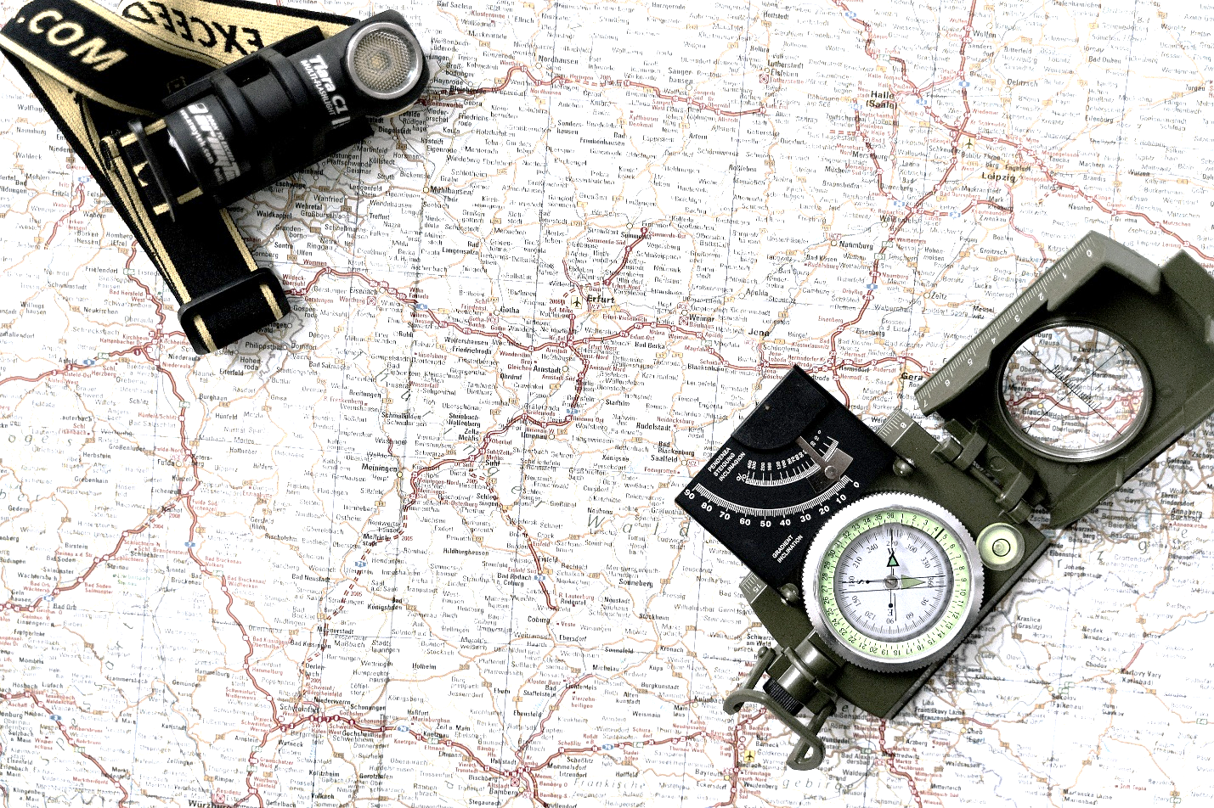

Pexels: tima-miroshniche

D. SURVIVAL SKILLS & SELF-RELIANCE POD

Purpose
The Survival Skills & Self-Reliance Pod focuses on helping community members learn practical skills that improve preparedness, safety, problem-solving, and independence during emergencies, disasters, or disruptions in critical resources. Its purpose is to encourage communities to prepare before crises occur by teaching useful everyday and emergency survival skills that help people become more confident, capable, and resilient.
This pod promotes practical education, preparedness, community cooperation, and skill-sharing to help reduce fear, confusion, and dependence during difficult situations.

Examples of Support
- Emergency preparedness education
- Food preservation and storage training
- Gardening and self-sufficiency skill workshops
- Basic first aid and safety training
- Generator, battery, solar panel, and emergency equipment education
- Fire safety and emergency planning support
- Basic repair and maintenance workshops
- Communication and emergency radio education
- Household emergency kit preparation guidance
- Community preparedness demonstrations and events

Examples of Community Support Systems
(Examples only. Inclusion does not imply formal participation or endorsement.)
- Emergency management organizations
- Fire departments and first responders
- Hardware and supply stores
- Local farms and gardening groups
- Community colleges and vocational programs
- Ham radio and emergency communication groups
- Outdoor and survival education groups
- Skilled trade professionals and volunteer instructors
- Community preparedness organizations
- Local businesses and community centers

Community Skills & Volunteers Needed
- Emergency preparedness educators
- Gardeners and food preservation volunteers
- Skilled trade professionals and repair workers
- First aid and CPR trained individuals
- Ham radio and communication volunteers
- People familiar with generators, solar equipment, or emergency tools
- Community workshop and event volunteers
- Safety educators and outreach volunteers
- Individuals willing to teach practical life and preparedness skills

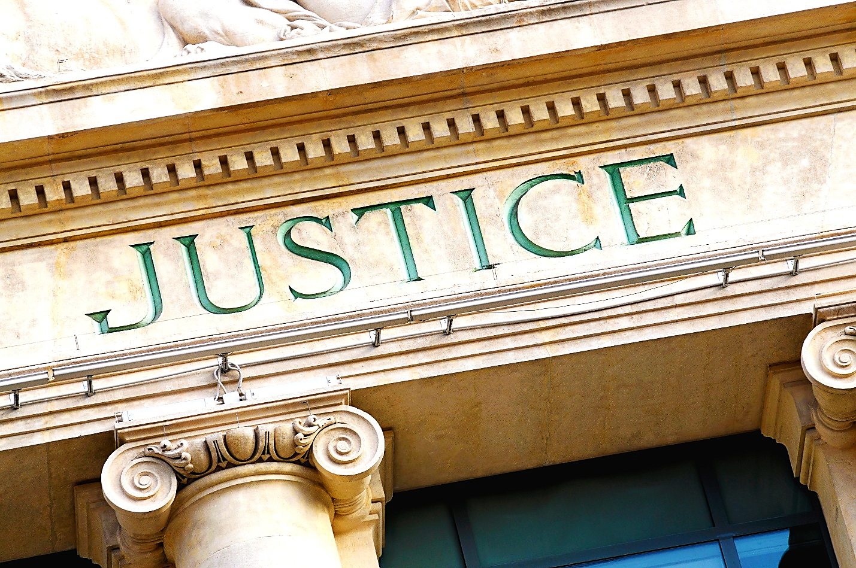
Adobe Stock: 81419291

E. LEGAL & JUSTICE POD

Purpose
The Legal & Justice Pod focuses on helping community members understand their rights, access legal guidance, connect with advocacy resources, and receive support during times of crisis, hardship, displacement, or uncertainty. Its purpose is to encourage communities to prepare ahead of time by improving awareness of legal protections, community resources, advocacy systems, and support services that may help individuals and families navigate difficult situations more safely and confidently.
This pod promotes education, fairness, communication, advocacy, and community support while helping vulnerable individuals better understand available protections and resources.

Examples of Support
- Legal aid and advocacy referrals
- Housing and tenant rights information
- Assistance understanding public benefits and community resources
- Community rights education and informational workshops
- Resource navigation and referral assistance
- Support connecting residents with trusted legal or advocacy organizations
- Assistance for vulnerable individuals during emergencies or displacement
- Translation and accessibility support for legal or resource-related information
- Community outreach and informational support events

Examples of Community Support Systems
(Examples only. Inclusion does not imply formal participation or endorsement.)
- Legal aid organizations
- Disability advocacy organizations
- Tenant rights groups
- Community outreach programs
- Public service and social service agencies
- Volunteer attorneys and legal professionals
- Churches and nonprofit organizations
- Translation and accessibility support groups
- Civil rights and community advocacy organizations
- Local community support organizations

Community Skills & Volunteers Needed
- Lawyers, paralegals, and legal advocates
- Community outreach volunteers
- Translators and accessibility support volunteers
- Individuals willing to help residents navigate resources and services
- Social workers and advocacy volunteers
- Community organizers and support coordinators
- Volunteers able to assist with communication and informational outreach
- Individuals willing to help vulnerable residents connect with support systems

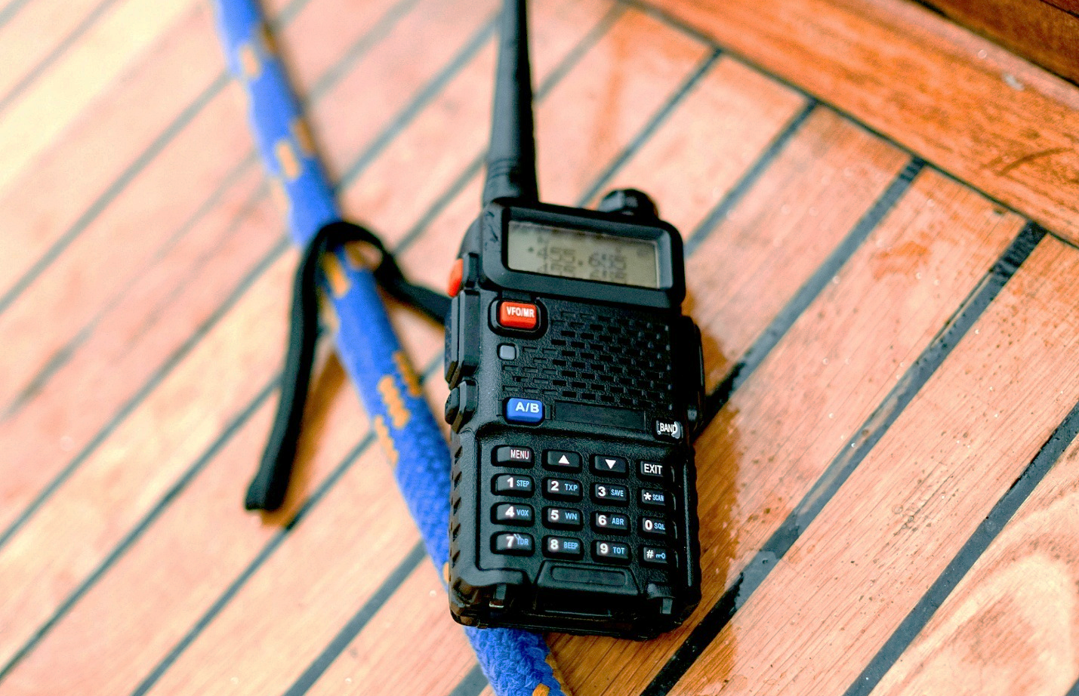
Pexels: CottonBro 537093

F. COMMUNICATION & OUTREACH POD

Purpose
The Communication & Outreach Pod focuses on helping communities stay informed, connected, organized, and supported during emergencies, disasters, or disruptions in normal communication systems. Its purpose is to encourage communities to prepare ahead of time by developing communication networks, outreach systems, resource-sharing methods, and community connections that help reduce confusion, isolation, and misinformation during times of crisis.
This pod promotes communication, accessibility, preparedness, inclusion, and community awareness while helping ensure important information reaches as many people as possible, including vulnerable populations who may lack access to phones, internet, transportation, or traditional media.

Examples of Support
- Community alerts and emergency communication updates
- Neighborhood check-in and outreach systems
- Phone trees and volunteer communication networks
- Social media and community information sharing
- Printed flyers, resource guides, and public information distribution
- Outreach support for elderly, disabled, homebound, or isolated individuals
- Translation and accessibility support for communication materials
- Community resource and event announcements
- Emergency preparedness and awareness campaigns
- Coordination between pods, volunteers, organizations, and residents

Examples of Community Support Systems
(Examples only. Inclusion does not imply formal participation or endorsement.)
- Local media organizations
- Libraries and community centers
- Schools and educational organizations
- Churches and faith-based groups
- Ham radio and emergency communication groups
- Community outreach organizations
- Technology and internet service organizations
- Volunteer and neighborhood groups
- Public service organizations
- Social media and communication volunteers

Community Skills & Volunteers Needed
- Writers, designers, and communication volunteers
- Social media and technology volunteers
- Translators and accessibility support volunteers
- Community outreach and neighborhood support volunteers
- Ham radio and emergency communication volunteers
- Individuals willing to distribute flyers or information
- Event coordinators and organizers
- Volunteers able to check on isolated or vulnerable residents
- Individuals skilled in public communication and resource coordination


Adobe Stock: 259268744

G. RESOURCE & FUNDING POD

Purpose
The Resource & Funding Pod focuses on helping communities organize, collect, manage, and distribute resources, donations, supplies, and financial support during emergencies, disasters, or periods of hardship. Its purpose is to encourage communities to prepare ahead of time by identifying potential funding sources, organizing community support systems, and coordinating resources that may help individuals and families during times of crisis.
This pod promotes preparedness, cooperation, transparency, community support, and resource coordination while helping communities strengthen their ability to respond to changing needs and limited resources.

Examples of Support
- Community donation drives and supply collection
- Emergency resource and supply coordination
- Fundraising and community support events
- Grant and funding opportunity identification
- Distribution of hygiene supplies, food, blankets, batteries, and emergency items
- Resource tracking and organization assistance
- Financial literacy and budgeting education
- Community mutual aid and support coordination
- Assistance connecting residents with available resources and support programs
- Volunteer support for organizing and distributing community supplies

Examples of Community Support Systems
(Examples only. Inclusion does not imply formal participation or endorsement.)
- Charitable organizations
- Community foundations and charitable organizations
- Churches and faith-based organizations
- Local businesses and business owners
- Nonprofit organizations and outreach programs
- Schools and community centers
- Volunteer and neighborhood groups
- Local fundraising and civic organizations
- Grant and philanthropic organizations
- Community support and mutual aid groups

Community Skills & Volunteers Needed
- Fundraising and event volunteers
- Grant writing and budgeting volunteers
- Organizers and inventory coordinators
- Community outreach and support volunteers
- Business owners and donation coordinators
- Individuals willing to sort, distribute, or organize supplies
- Financial literacy and budgeting educators
- Volunteers able to assist with transportation and deliveries
- People willing to help connect residents with resources and support programs


Adobe Stock: 663880837

H. MEDICAL & HEALTHCARE POD

Purpose
The Medical & Healthcare Pod focuses on helping community members access healthcare support, wellness resources, medical information, basic care coordination, specialist care, medication support, and community health assistance during emergencies, disasters, or periods of hardship. Its purpose is to encourage communities to prepare ahead of time by strengthening healthcare support systems, improving communication, and helping vulnerable individuals remain connected to important medical resources and services.
This pod promotes preparedness, compassion, wellness, accessibility, and community support while helping reduce isolation and barriers to healthcare during times of crisis or disruption.

Examples of Support
- Wellness check-ins for elderly, disabled, ill, or homebound individuals
- Assistance connecting residents with healthcare resources and clinics
- Medical supply and prescription coordination support
- Transportation assistance for medical appointments or pharmacy pickups
- Community health education and preparedness information
- First aid and basic safety education
- Support for individuals managing chronic illness or medical conditions
- Specialist care resource education, including oncology, endocrinology, cardiovascular care, dental, vision, orthopedics, and other specialty needs
- Emergency healthcare communication and outreach support
- Assistance identifying local healthcare and wellness resources
- Community support for vulnerable populations during emergencies

Examples of Community Support Systems
(Examples only. Inclusion does not imply formal participation or endorsement.)
- Healthcare providers
- Medical centers and hospitals
- Medical clinics
- Community healthcare organizations
- Public health organizations
- Local pharmacies and healthcare providers
- Specialty clinics and professional healthcare groups
- Churches and community outreach organizations
- Veteran and disability support organizations
- Home healthcare and caregiving organizations
- Volunteer healthcare and wellness groups

Community Skills & Volunteers Needed
- Doctors, nurses, CNAs, EMTs, and healthcare professionals
- Specialist care professionals, including dental, vision, oncology, orthopedic, endocrine, and cardiovascular providers
- Caregivers and home health support workers
- Drivers willing to assist with transportation needs
- Community outreach and wellness volunteers
- Individuals trained in CPR or first aid
- People willing to check on vulnerable residents
- Volunteers able to help organize medical supplies or resources
- Translators and accessibility support volunteers
- Individuals willing to assist residents with navigating healthcare resources and services

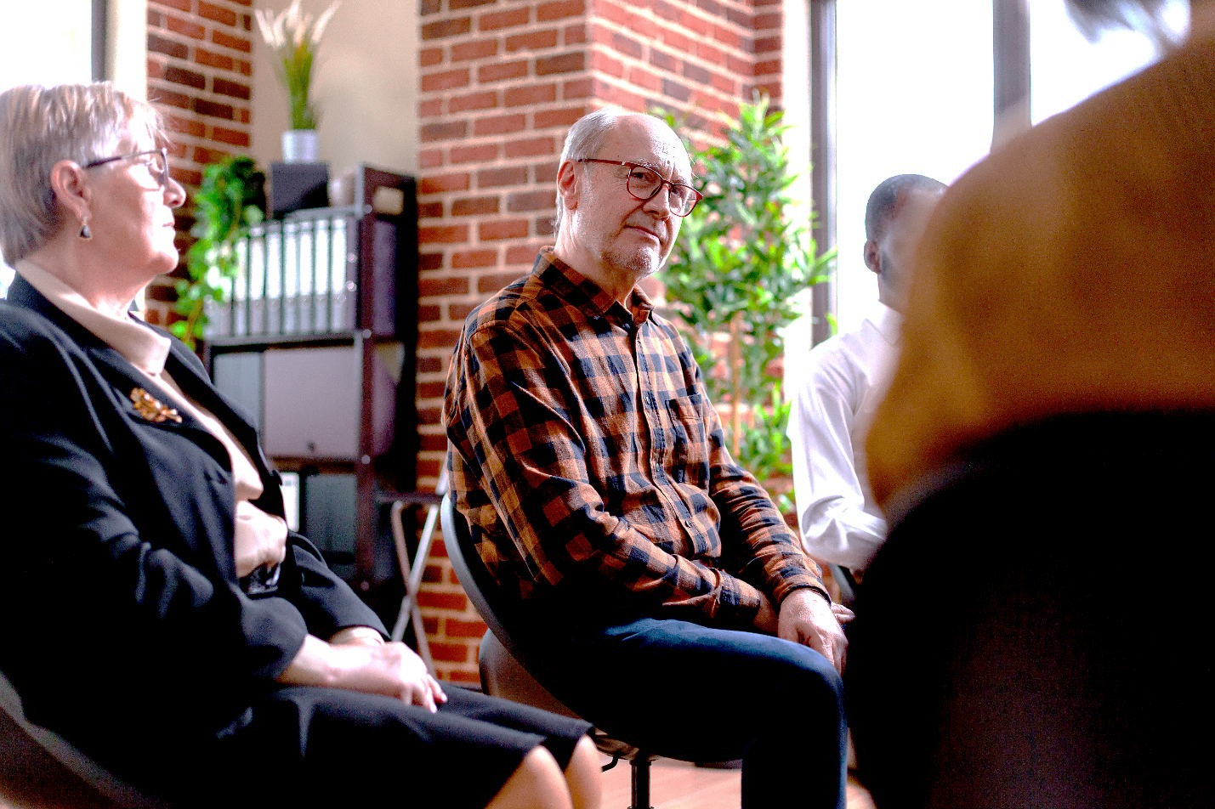
Adobe Stock: 476675687

I. MENTAL HEALTH & EMOTIONAL SUPPORT POD

Purpose
The Mental Health & Emotional Support Pod focuses on helping community members access emotional support, mental health resources, crisis assistance, peer connection, and wellness support during emergencies, disasters, hardship, or periods of uncertainty. Its purpose is to encourage communities to prepare ahead of time by strengthening emotional support systems, reducing isolation, and helping individuals remain connected to compassionate care and community support during difficult situations.
This pod promotes compassion, emotional wellness, communication, crisis awareness, peer support, and community resilience while helping reduce fear, confusion, loneliness, and emotional distress during times of crisis or disruption.

Examples of Support
- Emotional wellness and peer support check-ins
- Mental health resource and crisis support information
- Community support groups and wellness outreach
- Assistance connecting residents with counseling or mental health resources
- Crisis communication and emotional support outreach
- Support for individuals experiencing anxiety, grief, trauma, stress, or isolation
- Wellness education and mental health awareness support
- Outreach support for elderly, disabled, ill, or isolated individuals
- Community events focused on emotional wellness and support
- Resource coordination for vulnerable individuals and families

Examples of Community Support Systems
(Examples only. Inclusion does not imply formal participation or endorsement.)
- Community mental health organizations
- Counselors, therapists, and social workers
- Crisis and peer support organizations
- Churches and faith-based organizations
- Disability and advocacy organizations
- Community outreach programs
- Hospitals and healthcare providers
- Wellness and support groups
- Veteran and family support organizations
- Volunteer wellness and outreach organizations

Community Skills & Volunteers Needed
- Counselors, therapists, social workers, and peer support volunteers
- Crisis support and wellness outreach volunteers
- Compassionate listeners and support coordinators
- Community outreach and check-in volunteers
- Individuals willing to support isolated or vulnerable residents
- Wellness educators and support group volunteers
- Translators and accessibility support volunteers
- Volunteers able to assist with communication and resource navigation
- Individuals willing to help organize wellness and support events


Adobe Stock: 537638398

J. POWER & ENERGY POD

Purpose
The Power & Energy Pod focuses on helping communities prepare for power outages, energy disruptions, utility failures, extreme weather events, and emergency energy needs during times of crisis or hardship. Its purpose is to encourage communities to organize energy-related resources, improve preparedness, and help vulnerable residents maintain access to critical power needs before emergencies occur.
This pod promotes preparedness, safety, resilience, accessibility, and community cooperation while helping communities reduce the risks associated with power loss, communication failures, heating and cooling disruptions, and limited access to emergency energy resources.

Examples of Support
- Emergency generator and backup power support
- Solar panel and battery preparedness education
- Emergency charging stations and power access coordination
- Distribution of batteries, flashlights, and emergency supplies
- Community warming and cooling center support
- Education on safe generator and energy equipment use
- Support for resident’s dependent on powered medical equipment
- Emergency lighting and communication support
- Coordination of fuel, battery, and emergency power resources
- Community preparedness planning for extended outages or utility disruptions

Examples of Community Support Systems
(Examples only. Inclusion does not imply formal participation or endorsement.)
- Utility companies and public service providers
- Hardware and supply stores
- Solar and renewable energy organizations
- Emergency management organizations
- Community centers and churches
- Schools and local emergency shelter locations
- Local electricians and skilled trade professionals
- Community preparedness and response groups
- Volunteer outreach and neighborhood organizations
- Local businesses willing to assist with emergency energy resources

Community Skills & Volunteers Needed
- Electricians and skilled trade professionals
- Individuals familiar with generators, batteries, solar panels, or emergency equipment
- Community preparedness and safety volunteers
- Drivers and supply distribution volunteers
- Volunteers able to assist elderly, disabled, or medically vulnerable residents
- Individuals willing to teach safe energy and generator practices
- Outreach and communication volunteers
- People able to organize emergency charging or resource stations
- Volunteers willing to help with setup, distribution, and emergency support coordination



Adobe Stock: 62329886

K. EDUCATION & JOB TRAINING POD

Purpose
Supports learning, job readiness, practical training, career development, and community education during times of uncertainty or crisis.

Examples of Support
- Job readiness and resume assistance
- Interview preparation and career guidance
- Tutoring and educational support
- Adult learning and skill-building classes
- Computer, communication, and technology training
- Financial literacy and budgeting education
- Trade skill workshops and certification guidance
- Community resource and workforce connection assistance

Examples of Community Support Systems
(Examples only. Inclusion does not imply formal participation or endorsement.)
- Parkland College
- Illinois WorkNet Center
- Local schools and libraries
- Workforce development organizations
- Community colleges and vocational programs
- Local businesses and employers
- Career centers and mentoring programs
- Community organizations and nonprofits

Community Skills & Volunteers Needed
- Teachers, tutors, and mentors
- Trade professionals and skilled workers
- Business owners and hiring managers
- Resume and interview coaches
- Computer and technology volunteers
- Financial literacy educators
- Retired educators and professionals
- Volunteers willing to teach practical life or career skills


Photo Credit: mikenr-hyundai-496466819

L. TRANSPORTATION POD

Purpose
The Transportation Pod focuses on helping community members access safe, reliable transportation and delivery support during emergencies, disasters, hardship, or disruptions in normal transportation systems. Its purpose is to encourage communities to prepare ahead of time by organizing transportation resources, volunteer support systems, and delivery coordination that may help vulnerable residents remain connected to food, healthcare, shelter, supplies, and critical services during times of crisis.
This pod promotes preparedness, accessibility, safety, mobility, and community cooperation while helping reduce isolation and transportation barriers for elderly individuals, people with disabilities, homebound residents, families, and vulnerable populations.

Examples of Support
- Transportation assistance for medical appointments and pharmacy pickups
- Food, water, hygiene, and emergency supply deliveries
- Transportation to shelters, warming centers, cooling centers, or community resource locations
- Volunteer driver and ride coordination programs
- Delivery assistance for elderly, disabled, ill, or homebound individuals
- Emergency evacuation and relocation support coordination
- Transportation assistance during severe weather or utility disruptions
- Coordination of community supply movement between pods or support locations
- Accessibility transportation support and resource connection
- Community communication regarding transportation resources and availability

Examples of Community Support Systems
(Examples only. Inclusion does not imply formal participation or endorsement.)
- Champaign-Urbana Mass Transit District (MTD)
- Churches and faith-based outreach programs
- Disability and senior support organizations
- Community outreach and volunteer organizations
- Healthcare transportation providers
- Local businesses and delivery services
- Schools and community centers
- Volunteer driver and neighborhood support groups
- Emergency management and response organizations
- Community preparedness and mutual aid groups

Community Skills & Volunteers Needed
- Volunteer drivers with reliable transportation
- Delivery and supply distribution volunteers
- Community outreach and scheduling volunteers
- Individuals familiar with accessibility and mobility needs
- Volunteers willing to assist elderly, disabled, or homebound residents
- People able to help organize transportation coordination and communication
- Individuals willing to assist during severe weather or emergency situations
- Volunteers able to help move supplies, equipment, or resources between locations
- Community support volunteers willing to check on isolated residents

About the Creator
Melissa Kaye Swaney created the Community-Powered Blueprint as an independent community preparedness and support project focused on communication, preparedness, accessibility, compassion, and stronger local support systems.
Like many people, Melissa has listened to growing concerns shared through the news, social media, online community discussions, and conversations with neighbors, friends, coworkers, and family members about emergencies, rising costs, healthcare struggles, housing instability, disasters, and uncertainty about the future.

After repeatedly hearing people ask questions such as:
“What do we do?”
“How do we prepare?”
“How do communities help each other during difficult times?”
She began developing the Community-Powered Blueprint as a practical framework designed to encourage preparedness, communication, resource-sharing, and stronger community support systems before emergencies or hardships become more severe.
Melissa holds a Master’s Degree in Communication & Leadership from Eastern Illinois University, along with formal education and training related to communication, leadership, crisis management planning, and community-centered support systems.
This project is intended to encourage discussion, preparedness, cooperation, compassionate support, and stronger community connections.

Independent Community Preparedness Disclaimer
Community-Powered Blueprint is an independent educational and community preparedness initiative created by Melissa Kaye Swaney, an independent community advocate with a background in communication, leadership, and formal crisis management planning education.
The purpose of this blueprint is to encourage preparedness, communication, accessibility, volunteerism, community cooperation, and stronger local support systems before emergencies or major disruptions occur.
This project is intended to encourage discussion, planning, local problem-solving, compassionate community support, and practical preparedness efforts that may help communities strengthen resilience before crises occur.
Community-Powered Blueprint is NOT:
- A government agency
- An emergency management department
- A nonprofit organization
- A business
- A healthcare provider
- A transportation authority
- A housing authority
- A public utility
- Or an officially authorized emergency response organization
This project is not formally affiliated with, endorsed by, partnered with, employed by, operated by, or representative of any government agency, nonprofit organization, healthcare system, emergency management office, transportation provider, business, educational institution, or official organization unless explicitly stated otherwise.
Any references to organizations, professions, services, businesses, resource types, or community support systems are provided for general educational and planning purposes only and do not imply formal participation, endorsement, operational involvement, responsibility, or partnership.

Organizations & Community Participation
Organizations, businesses, volunteers, professionals, and community members who value preparedness, accessibility, compassionate support, and community cooperation are welcome to reach out if they are interested in learning more about the Community-Powered Blueprint, sharing ideas, offering feedback, or exploring ways communities may be able to strengthen local support systems together.

No one does everything. Everyone does something.

